FEPPS Instructor Training Guide

Table of Contents
Relevant FEPPS Staff List & Contact Information
Introduction
Welcome to FEPPS!
Notes on Language
Getting to Know the Environment
Prison Layout & Terminology
Demographic Trends of Incarcerated Students
Understanding our Students’ Circumstances
FEPPS Expectations for Instructors Engaging with Incarcerated Students
Other Prison Norms & Rules to Know
Pedagogy In Practice
FEPPS Pedagogical Principles
Trauma-Responsive Teaching
Universal Design for Learning Framework
Curriculum Development Details & Logistics
Classroom Infrastructure & Supplies
Curriculum & Lesson Plan Development
Other Relevant Resources Available to Students
Additional Resources for Continued Learning
References
Appendix
Syllabus Review (Example)
Mid-Quarter Check-In (Example)
Letter to Student in Segregation (Example)
COL 101: Student Success (Example Syllabus)

Relevant FEPPS Staff List & Contact Information
Alyssa Knight | Executive Director | alyssaknight@fepps.org
Shohei Morita | Academic Program Manager | shohei.morita@doc1.wa.gov
Evelyn Clark | Program Operations Manager | evelyn.clark1@doc1.wa.gov
Andrew Campbell | Classroom Support Coordinator | andrewcampbell@fepps.org
Liam Nold | Education Navigator & Admin Assistant| liamnold@fepps.org
WCCW Phone #: 253-858-4200
Main Control Ext.: 82310
Public Access Ext.: 82510
School Officer Ext.: 82377
_______________________________________________________________________

Introduction

Welcome to FEPPS!
We are so excited to have you join our learning community, and grateful that you have chosen to support the education of our talented students. While there are many experiences of teaching that are consistent across prison walls, there are also significant differences that are important for instructors to be aware of.
This guide is separated into three sections: Getting to Know the Environment, Pedagogy in Practice, and Curriculum Details & Logistics. The first section of this guide, Getting to Know the Environment, provides an overview of prison infrastructure, terminology, and policies, in addition to how they impact the day-to-day reality and education of our students. The second section, Pedagogy in Practice covers FEPPS Pedagogical principles, as well as foundational knowledge of important educational frameworks: Trauma Responsive Teaching & Universal Design for Learning, that should inform your teaching practice. Throughout these two sections are ‘Implementation Considerations,’ which highlight responsive strategies and best practices FEPPS staff and instructors have utilized to implement pedagogy in practice and be responsive to the challenges of the prison environment. The third section, Curriculum Development Details & Logistics includes details about the classroom, supplies, and logistical processes for developing & executing your course curriculum with FEPPS. Finally, we conclude with additional recommendations for continued learning, citations, and an appendix of examples referenced throughout the document.

Notes on Language
- We know the words we use to describe our work and community matters. We are committed to using person-first language when talking about people who are incarcerated and refrain from using derogatory labels such as inmate, offender, criminal, etc.
- We also affirm that not everyone incarcerated at Washington Corrections Center for Women (WCCW) identifies as a woman. Therefore, we use gender inclusive and affirming language when talking to, with, and about the people in our community and student body.
_______________________________________________________________________

Getting to Know the Environment

Prison Layout & Terminology
Like all bureaucracies and sub-cultures there is specific terminology utilized regularly in the prison that are unique to this environment. Below is a map of the Washington Correction Center for Women, followed by a brief description of specific locations and terminology within the facility that are most relevant to FEPPS instructors.

Buildings & Infrastructure
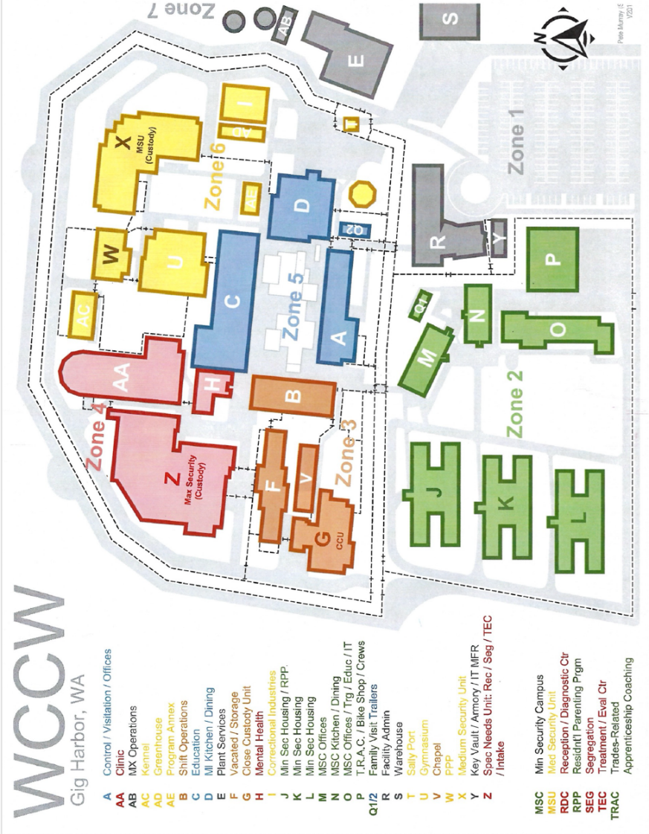
Education Building (C) - is located directly across from the entrance (A) to the facilities campus (Zone 5). This requires you to have received your badge and gone through security at Public Access (R); then scanned in at main control (A) and passed through the various sets of barbed wire and metal gates in-between. The education building has 8 classrooms, state library, law library, administrative offices, and Correctional Industries (“CI”). Further details are provided in Curriculum Development Details & Logistics.
FEPPS Staff Office – where you can access FEPPS staff if you need support! To access it, walk past the officers’ podium toward the state library, turn left, walking past the tool cabinet, and our office is directly in front.
Minimum Security Campus (Zone 2), “the hill” - least restrictive living units at the facility, including pods J, K, and L as well as some administrative buildings.
Medium Security (X), “MSU” - Medium Security is made up of two living units or pods, called MS-A and MSU-B.
Closed Custody Unit (G), “CCU” - The most restrictive living unit at the facility, also has two distinct pods: East and West.
Treatment & Evaluation Center (Z), "TEC” - This section of the prison is designated for people who need additional support with cognitive impairments, disabilities, or mental illness. It is separated into TEC Acute, for short term support, and has a small number of full-time residents living in TEC Residential.
Close Observation Area, (Z) “COA” - area designated for people experiencing mental health crisis, can be self-admitted or required by DOC.
Segregation, (Z) “SEG / solitary / max / the hole” - custody unit for individuals under investigation or as punishment for breaking DOC policy, in which they are kept in their cell for 23 hours a day and barred from all programming. (See “Supporting Students in SEG”; and learn more about the impact of segregation here)

Scheduling Terminology
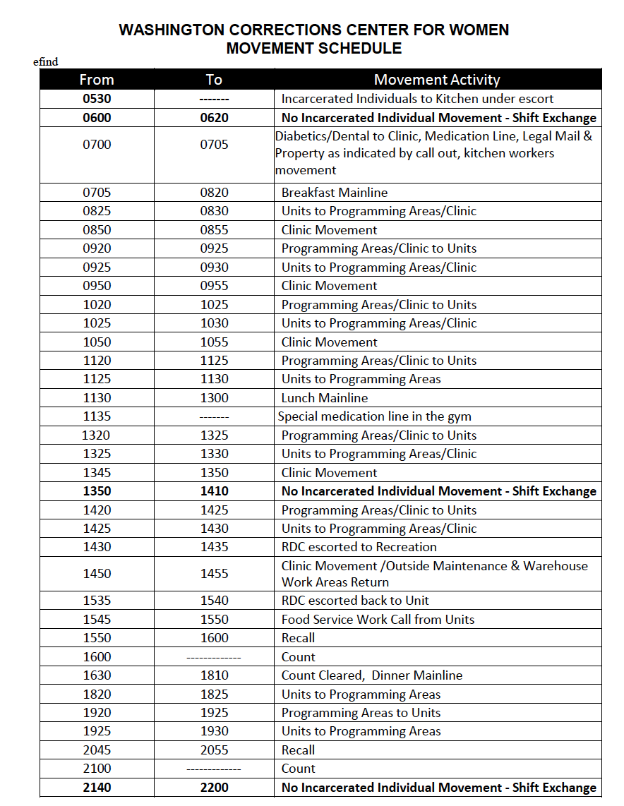
Callout – A list generated for each programming block of every day, with who is supposed to be there. If someone is not on the callout, they are not able to attend. Callouts are created by program coordinators and must be submitted by a specific time each day. Callouts can be mandatory or optional – if someone does not show up when on a mandatory callout, they can receive an infraction. FEPPS callouts are ‘optional’, meaning that students do not face repercussions with DOC if they miss class.
Movement – designated time each hour of the day during which people who are incarcerated can move from one place to another. Movements are announced over the speaker by a CO in each building.
Recall – the movement at the end of a programming block, during which people are “recalled” to their living units.
Cease Movement – period during which no one is allowed to move around the prison, because of something occurring in the facility. This includes those of us with badges, so hang tight wherever you are. Sometimes they are short, sometimes they take hours.
Restricted Movement – Same as a cease movement, except it applies only to people who are incarcerated. Incarcerated individuals can move only if escorted by staff. You can leave during a restricted movement, assuming you are not supervising anyone who is incarcerated.
Main Line – term used for lunch, that is supposed to occur daily from 12:30-1:20pm. If you teach at 1:30, you may hear the CO say something like “main line ran late today” explaining why your students are not yet there.
Clinic Movement - when people have access to get their medications or check in briefly with a health care professional; it might occur during your class – students generally can go and return within 30 minutes.

Misc. Relevant Terms
Infraction – a negative mark put on someone’s record, that can accumulate to various punishments from the DOC (learn more about prison misconduct policies here).
Securus – messaging system used by people who are incarcerated to communicate with friends, family, and community outside of the facility; available to them on their tablets.
Kiosk – internal messaging system used by DOC and programs within the facility to communicate with people who are incarcerated, sort of like email.
CO – Correctional Officer
DOC – Department of Corrections

Demographic Trends of Incarcerated Students
Since FEPPS founding in 2012, we have proudly graduated over 100 students from our Associate's Degree program through Tacoma Community College, and 8 students from our Bachelor’s Degree program through the University of Puget Sound. Due to restrictions on data collection, we have extremely limited demographic information on our current FEPPS students. There is also limited disaggregated data nationally, particularly for women and gender non-conforming people. We provide here general demographic trends about the millions of people in the U.S. who are subject to incarceration (NOTE: data collection did not include options outside the gender binary)
- Washington state incarcerates a higher percentage of its population than any democratic country in the world, at 373 per 100,000 residents (Prison Policy Initiative, 2025).
- Black, Indigenous, and other people of color are incarcerated at disproportionate rates. In Washington state, Black people are incarcerated at a rate of 4.4x in comparison to their white counterparts and indigenous people at a rate of 3.6x (Vera Institute of Justice, 2019).
- It is estimated that 50% of women in prison have some type of learning or cognitive disability, and more than 2/3 have one or more mental health diagnosis (Prison Policy Initiative, 2025).
- Lesbian, gay, and bisexual people are incarcerated at 3x the rate of heterosexual people (Bertram, 2024).
- One in six trans people are incarcerated during their lifetime. Nearly half of Black trans people are incarcerated (Bertram, 2024).
- The most comprehensive report on corrections education was in 2003, which found that 68% of people in prison entered without a high school diploma or equivalent (Wolf Harlow, 2003). More recent research on women's incarceration trends shows over half continue to enter without a high school diploma (Kajstura. & Sawyer, 2024).
- Roughly 60% of women in prison are parents to minor children (Kajstura. & Sawyer, 2024).
- An estimated 53% of women were jobless the month prior to their arrest, and 26% were experiencing homelessness (Kajstura. & Sawyer, 2024).

Understanding our Students’ Circumstances
While there are many similarities between students you have taught previously and FEPPS students, there are also significant differences for our students in terms of agency, resources, lived experience, and environment that are critical for you to know in preparing your curriculum for FEPPS. Below is a summary of these differences for you to be aware of.

Restricted Agency & Movement, & Communication
The daily lives of people who are incarcerated are closely controlled and surveilled by the DOC. Individuals must be placed on a callout by DOC or contract staff to attend any and all programming outside of their living unit. Their badges are scanned when leaving a destination and re-scanned when they arrive at their next location. Additionally, there are designated times, generally each hour, that are designated for people that are incarcerated to move, like ‘passing periods’ at the outside university.

Throughout daily programming, there is both a first and second movement each hour. First movement, typically 20 minutes after the hour, allows incarcerated individuals to go back to their living unit, and about 10 minutes later is the second movement, which allows them to go to whatever they have scheduled for the next time block. If someone is found by DOC outside of where they are supposed to be, within the designated times provided, they may face consequences. This means that FEPPS students do not have the flexibility to come before or stay after class, to speak with the professor.

There is no access to the internet inside of the facility available to instructors or students (‘Curriculum Development Details & Logistics’ explains how we adapt as educators). While incarcerated individuals do have a messaging system, Securus, to communicate with people outside of the prison, DOC policy prohibits staff and volunteers from utilizing this platform. Our students can message FEPPS staff via Kiosk, however, these messages are checked by our staff who then must email the message to you, and your response back to the student. Thus, Kiosk is not a reliable form of communication for you and your students to utilize for time sensitive conversations.

Implementation considerations:
- Anything you need to communicate about with students should be done during your class period. Your lesson plans should include designated time for questions, as well as for students to pull you into the hallway to discuss personal concerns, questions, or needs.
- Your students may not be able to contact you about missing class, nor can they send you an email asking to clarify readings, deadlines, or assignment requirements. A detailed syllabus is crucial for students, as are thorough assignment descriptions, grading rubrics, and at least two weeks' notice for assignment deadlines.
- Encourage students on the first day to find a buddy within the class that lives in their same unit. Buddies can help with letting you know if/why someone is unable to make it to class, bring assignments, take materials for a missed class, etc.
- Develop flexible deadlines, floating assignments, or late policies that are responsive to students’ limited agency over their whereabouts and inability to communicate with you outside of class.

Complex Relationships
Some of your students may be new to the facility, while others may have been there for decades. Many FEPPS students have long-standing, inescapable relationships (as family, friends, romantic partners, exes, or enemies) when they enter your classroom, and what occurs in the classroom may follow them home.
If FEPPS is aware of a complex relationship between students in your course, we will let you know in advance. However, it may also happen that a student communicates the desire to stay separated from another classmate, for whatever reason, directly to you. We encourage you to utilize your best judgment in these scenarios and communicate with Shohei or another FEPPS staff member in problem-solving these situations.

Implementation Considerations:
- Intentional time is needed for creating, reviewing, and implementing classroom community agreements. Designate time on the first day of class for students to self-reflect and talk in pairs/small groups before a group discussion of community agreements. Encourage clarity – i.e. "what does that look like in practice?” Bring copies of the community agreements to the next class, have each person read aloud one agreement and explain what it means. Talk through questions as a group, does anything need to be re-worded or added? Revisit them again after a few weeks, updating as necessary, and refer to them throughout the quarter as is useful.
- If creating assigned seats, groups for a project, or other scenario in which you designate who students must interact with, be mindful of these dynamics and the possible need for quick adjustments. Let students know in advance that you will be randomizing seating on certain days or assigning groups, so they can mentally prepare and/or speak with you about concerns. Noting that relationships tend to be more complex in this classroom setting does not mean that you should cut randomized seating/groups from your teaching practice – the opportunity to build new relationships, practice communication skills, find common ground, and expand their perspectives are significant to students’ education.
- Spend some time reflecting on how you might handle breaks of classroom community agreements, interpersonal conflict in class, or other issues should they arise.

School-to-Prison Pipeline & Educational Trauma
The school-to-prison pipeline refers to systemic policies and practices that push marginalized students—particularly students of color, those with disabilities, LGBTQ+ students, and those from low-income backgrounds—out of the education system and into the criminal legal system. Harsh disciplinary measures such as zero-tolerance policies, increased policing in schools, and exclusionary practices contribute to this pipeline by criminalizing behaviors that are typical of adolescents. This and other negative experiences can result in educational trauma.
Educational trauma occurs when students experience harm within educational institutions, leading to disengagement, distrust, and negative associations with learning. Many incarcerated students have faced exclusionary discipline, inadequate support, and systemic barriers that impacted their academic success before their incarceration. Addressing these traumas through inclusive, accessible, and trauma responsive teaching can help rebuild trust and engagement in education.
Implementation Considerations:
- Review thoroughly the “Trauma-Responsive Teaching” portion of this guide, as well as supplemental learning on the topic if it is new to you.

Increase Likelihood for Change / Inconsistency
Last-minute changes and the need for flexibility are always present for educators, but even more so in this environment. Due to staffing shortages, bureaucracy, and the challenges of housing and controlling hundreds of people – it is relatively common for things at the prison to not go as planned. There are unplanned cease-movements, restricted movements, CO variability in policy enforcement, and various other factors that can throw a wrench into the schedule. It is impossible to come fully prepared but entering the prison with a mindset of –going with the flow, riding the waves, etc. - will be helpful to you in navigating this environment. We trust that you will do your best and know that FEPPS staff are here to help when it’s time to pivot.

FEPPS Expectations for Instructors Engaging with Incarcerated Students
- Always arrive at the facility no later than 30 minutes before your class start time. It can take significant time to go through security and get to the education building, depending on what else is occurring at the facility. If you are not at the education building when students arrive, they will be sent back to their units by the School Officer.
  - If you are running late, or need to cancel class, please text/call Shohei AND email him at his DOC address (shohei.morita@doc1.wa.gov). You may also call the School Officer, who can inform students of the cancellation, or depending on your timing, may be willing to keep them in the lobby until you arrive.
- At no point should you be asking students about why they are in prison or searching for this information when you leave the facility. Someone may choose to disclose this information to you or the class, but it is critical that we respect individual's agency in sharing or discussing their private information.
- Except for being in immediate danger, there are no circumstances in which you should take an issue directly to a CO or DOC staff member, before first talking with FEPPS staff. Reporting students to DOC can lead to significant consequences for our students, that FEPPS has no control over or input toward, including reprimand, removal of programming or benefits, time in Segregation, and additional time added to their prison sentence. We similarly ask students to please address any issues related to FEPPS with FEPPS staff first, rather than going directly to DOC.
- When you are in the classroom with students, as someone with a volunteer badge, you are the person responsible for supervision and enforcement of DOC policies, under the eyes of DOC. Tension exists between FEPPS values and that of the prison and navigating this can be challenging. If you, or students under your watch, are caught breaking DOC policy, it can lead to penalties not only for you, but our students and the program as a whole. While you may be willing to face the consequences of certain violations, please remember that you have the privilege of leaving at the end of the day, but our students do not.
- Cease movements and restricted movements occur with varying regularity in the prison. If either occurs before class, your students may not be able to come as scheduled. Often, in a two-hour block, students will be able to come for the second half of class, so please stay in the classroom. If it has passed the second block and the restricted movement is still happening, you are welcome to leave (e.g. if you were scheduled to start at 9:30am, and it’s now 10:40am). If a cease movement occurs while you are in class with students, you will all be required to stay in the classroom. If there is a restricted movement while you are in class with students, you are required to stay unless there is a FEPPS staff member in the building who can stay in the room with students.

Other Prison Norms & Rules to Know
There are many DOC policies that will be clear to you from the volunteer badge training and paperwork that you are required to complete, that we will not repeat here. It is very important for the safety of our students and the FEPPS program that you follow DOC policies, regardless of what we may think or feel about them. If you have questions or concerns about any of them, please speak with a FEPPS staff member. This section will cover the rules and norms that are not necessarily covered at the DOC training but are relevant to your work.

Security Culture
Unsurprisingly, there is a strict security culture within the prison. Here are miscellaneous things to know around security:
- Abide by PREA regulations, as explained by the DOC training. Especially relevant to the classroom are the following: ensure there is light on in the classroom at all times, window blinds are kept above the designated line, and that you are not in a room alone with less than three students.
- As a red badge volunteer, you should only be going to and from the education building within the facility. All doors are locked and/or manned by a DOC employee. Classroom doors are locked in between programming blocks, as are the computers. Ask the School Officer (CO at the front desk) to open your door and computer for you, when needed. It is your responsibility to re-lock the computer when leaving, and the CO’s responsibility to lock the doors.
- You are the person responsible for supervising FEPPS students during your class period. You cannot leave your classroom while students are there, apart from quick bathroom use or trip to the FEPPS office.
- Unfortunately, students are not allowed to be outside of the specific space written on their callout, so meandering the halls, getting a breath of fresh air, or hanging outside during class breaks is generally frowned upon by the COs and can cause issues. When students go to the bathroom, they should be taking the bathroom pass that is kept at the classroom door.
- You are allowed to close the classroom door - sometimes it can be noisy or distracting outside. The CO may occasionally come peak in your window or ‘check-in’ on the room.
- Scissors are meant to be kept in a locked drawer, so you will need to ask a DOC employee or FEPPS staff member with keys should you need scissors. The front desk CO and other teachers typically have a pair they can let you borrow.

Bathrooms
Across the facility bathrooms are segregated for those who are incarcerated versus those who are not. Regardless of whether you agree with this practice, it is something we must all comply with. In the education building, there is a bathroom across from the CO front desk that is only for people who are incarcerated. Do not use this bathroom. In the restricted area directly behind the CO desk, around the corner, is the bathroom for staff, volunteers, and guest visitors.
Names & Nicknames
Within DOC, everyone is referred to by their last name - including both those who are incarcerated and correctional officers. Within the incarcerated community, it is common for people to have a nickname, or alternative name they prefer rather than their last name. Generally, FEPPS staff and instructors encourage students to use their preferred name/nickname in our spaces, and you are of course welcome to introduce yourself to students however you’d like to be referred to. If you end up in a conversation with a DOC employee regarding a student, however, expect to use last names.
_______________________________________________________________________

Pedagogy In Practice

FEPPS Pedagogical Principles
We believe, a bell hooks writes, that education is a practice of freedom. FEPPS teachers commit to anti-racist, feminist, and decolonial teaching and learning as frameworks for that practice.
The core values of the FEPPS program emerge from a commitment to dismantling carceral systems and oppressive institutions that deny people’s humanity. The process of dismantling these systems includes immediate and sustained work. FEPPS strives in the short-term to increase the provision of degree-bearing higher education coursework for incarcerated individuals and to create a curriculum that provides access to degrees and rigorous academic courses. We also seek the immediate elimination of restrictions to higher education for restored citizens and more equitable access to higher education institutions.
Social justice pedagogies were and continue to be forged by radical Black women, feminist, and LGBTQ+ educators, activists, and theorists who understood the power of education as a catalyst for social change. Their movement building shows us how to organize and teach in ways that cultivate empowerment, leadership, and activism while building and sustaining community. We believe all classes should adhere to the goals of Black feminist and social justice pedagogy regardless of content or discipline. We suggest that no one-size-fits-all social justice pedagogy exists, but that we can center these principles and pedagogies as an integrated part of all the courses we design.
These include:
Decolonized Curriculum. Black feminism underscores the importance of valuing marginalized people’s lived experiences. Similarly, we strive to center the most marginalized in our curricula, classes, and governance. Our courses therefore strive to decolonize students’ knowledge acquisition by challenging traditional, Eurocentric narratives that silence and malign the existence, experiences, knowledge production, and creativities of Black, Indigenous, and People of Color (BIPOC). Decolonization means disrupting racist and imperialist legacies of structural violence by not only incorporating more diverse voices in our course content but also in recognizing the universality of those diverse experiences.
- What salient identities do you hold, and how do they inform your teaching practice?
  - How might your personal experience with the criminal legal system, or lack thereof, impact how you show up in the prison classroom?
- How does white supremacy, heteropatriarchy, or cisnormativity shown up in your field? What has the fight against injustice, inequality, or toward decolonization looked like in your field? How might you incorporate this into your curriculum?
- How can you be intentional about incorporating diverse perspectives in your course reading list? If your curriculum is already created, what perspectives are missing? How might you expand it even further?
- Where in your curriculum is there space for students to reflect on their salient identities and connect them to course material?
Empowerment. Power is a crucial part of a creative learning community. Power is not domination, but “energy, capacity and potential.” Power is the glue that holds the community. Rather than limiting power (as in an understanding of power as domination), in a social justice classroom the goal is to increase the power of all actors. A sense of power is crucial to students’ development and learning.
- How can you intentionally make space for, affirm, and uplift students’ power?
- How might you encourage students to empower one another within your classroom?
Classroom as Collaborative Community. The classroom cultivates a sense of mutuality, connection and care. Students share a sense of responsibility for the learning of others, not just their own. Our pedagogies center students’ participation in knowledge production via project based, problem-solving, and collaborative learning. Our curricula are structured to ensure that students are actively participating in their own development as intellectuals and engaged citizens. Collaborative teaching and learning in classrooms can decenter authority, welcome and elevate marginalized standpoints, and counteract hierarchies of white supremacy, colonialism, and heteropatriarchy through collective knowledge production.
- In what ways have you expressed care for students in past courses? How will you plan to do so in this space, while respecting DOC limitations?
- How will you foster community within your classroom? How can you create spaces that encourage connection and humanization, within an institution designed for the exact opposite?
Leadership. Developing leadership is an important part of the liberatory goals of a social justice classroom. Students gain leadership skills through responsible participation in the class. The social justice teacher serves as role model and helps members of the class develop a community, a sense of shared purpose, a set of skills for accomplishing that purpose, and the leadership skills so that teacher and students may jointly proceed on those tasks.
- What does leadership mean to you? How do you hope to model leadership for our students?
- How can your lesson plans and/or assignments create opportunities for students’ varied leadership styles to shine or grow?
- How can you name and affirm student leadership within your classroom?
Classroom as Contested Space. A contested space is a space open to conflict, open to the possibility of simultaneous truths, it must be able to incorporate personal experience and, at the same time, and understanding of (and resistance to) the ways that personal experience can be essentialized in order to close off analysis. Bell hooks argues that in a safe space classroom, we might strive for an environment that is free from domination or authority. In a contested space classroom, we know that no space is free from domination, so we examine the effects of power and privilege in our classroom environment.
- What steps will you take to create a classroom that allows for dialogue and disagreement?
- What practices have you used or witnessed that were effective at de-escalating conflict?
- What situations at work are most likely to activate your stress response system? What does it look like for you when your stress response is activated? What coping skills or strategies have you found that help you self-regulate, or what additional ones might you try?
Challenging Structural Inequality. We facilitate the examination and analysis of material in a way that transforms the traditional narrative of society and institutions while inspiring and equipping students to challenge injustice and structural inequality. We believe courses should develop a systems-minded analysis for individual and interpersonal experiences by connecting “local knowledges” to interlocking dynamics of disparity, power, and privilege. This includes: What questions do we ask and how do we ask them? How and where do we find the answers? What constitutes valid or “true” evidence? What are the stakes of our conclusions, and for whom?).
- How will you encourage students’ lived experience as a form of valuable knowledge production?
- When discussing systems of injustice or inequality, do you also include how people have and/or continue to resist these systems? How might you further uplift marginalized communities’ fight for liberation against oppression?
- How might you incorporate the work of incarcerated or liberated scholars within your curriculum?
Education as Healing-Engaged. We also reject the idea that those who are marginalized are depleted by trauma and oppression and are without hope or vibrancy. We learn from the Indigenous education scholar Eve Tuck (Unangax̂ ) who demands that we turn away from damage-centered trauma approaches and turn toward community-based, collaborative projects full of laughter, wholeness, and action to promote well-being and desire for change. This methodology disrupts white masculinist approaches to structures, policy, and knowledge production that govern higher education and evaluate people primarily from economistic and colonial standpoints and from deficit-based approaches. We believe education can be part of a healing engaged process rather than focusing solely on individual trauma.
- How will you make space for curiosity, joy, and creativity within your classroom?
- Do your course materials regarding marginalized communities or identities present them from a deficit or strength-based framework?
Cultivating Teacher Capacity. Teachers inside have the power to create transformative educational experiences. With little to no access to technology, inadequate instructional materials, and lack of support for learner variability, prison educators must be incredibly resourceful to meet the needs of their students. For many individuals in incarcerated settings, prison higher education faculty often serve as models for positive communication, interpersonal interaction, and study habits. We believe teachers are most effective when they demonstrate the skills of resourcefulness, knowledge of learner variability, modeling healthy interpersonal relationships, and ability to navigate prison culture. Instructors who are able to develop and apply these skills have greater capacity to meet the individual needs of their students.
- How can you prepare or set yourself up now, to be able to adjust your curriculum or lesson plans when unexpected issues arise?
- What are you most excited for, as you prepare to teach for FEPPS?
- What aspects of teaching for FEPPS do you feel least prepared for, or nervous about? What steps can you take to mitigate this? How can FEPPS support you?

Trauma-Responsive Teaching
Trauma, particularly when experienced early in life, has profound effects on brain development and learning. Many of our students have histories of significant trauma, in addition to experiencing the ongoing trauma of incarceration. Understanding the signs of trauma, their long-term consequences, and responsive practices can help educators create more supportive, engaging, and effective learning communities.

What is Trauma & How Prevalent is it?
Trauma is a response to deeply distressing or disturbing experiences that overwhelm an individual’s central nervous system. Trauma can result from a single event, chronic experiences, or can be passed down generationally. How an individual experiences a potentially traumatizing event is dependent on the internal and external resources they have available, as well as their cultural context. Trauma, especially when experienced in childhood, can have significant impacts on brain development, cognition, emotional well-being, and social functioning.
Most research of trauma utilizes what are called Adverse Childhood Experiences (ACEs), an identified 10 childhood adversities that significantly impact lifelong health and well-being, these include: physical, emotional, and sexual abuse; physical and emotional neglect, parental mental illness, substance abuse, or incarceration; domestic violence; and divorce or parental separation. Generally speaking, the more ACEs a person has experienced, the greater their risk of disrupted brain development, chronic illness, mental health disorders, substance abuse, and difficulties in learning and relationships. The average person within the U.S. has an ACE score of one and three, whereas the average ACE score for people in prison six (Daniels, 2022). While there are valid critiques and limitations to the ACE framework, this provides valuable context to the prevalence of trauma within our student population. Please note that the ACE measurement does not consider historic or systemic trauma, nor does it include trauma encountered as adults.

Trauma’s Impact on the Brain & Learning
Our brains are comprised of neuropathways, that are created or diminished automatically in response to what we experience. When trauma occurs, especially if chronic, the brain will often adapt in several ways:
Stress Response & Sense of Safety
The amygdala, where fear and emotion are controlled within the brain, can become hyperactive in an attempt to keep us safe. Cortisol levels, the body's stress hormone, are also dysregulated. This means that individuals may be hypervigilant and more likely to perceive threats, even in environments others may generally deem ‘safe’. This overactivation of the nervous system can manifest itself as anxiety, difficulty concentrating, distrust, difficulty regulating emotions, emotional outbursts, disassociation, and fatigue; interfering with motivation, social engagement, and learning.
Thinking and Decision-Making
The prefrontal cortex, which is responsible for executive functions like reasoning, problem-solving, and impulse control, is frequently underdeveloped for individuals who have experienced early trauma. This can impact the ability to focus, manage emotions, and engage in complex cognitive tasks.
Memory & Learning
The hippocampus, the part of our brain that processes and stores memories, can shrink due to prolonged stress. This can decrease memory retention and the ease with which one processes new information, posing challenges when it comes to learning new material.
These challenges are significant on their own, let alone in the prison environment where students are additionally experiencing the ongoing trauma of incarceration.

Trauma Responsive Teaching Practices
Best practices for trauma responsive teaching include prioritizing relationships, establishing (relative) safety, practicing consistency and transparency, and increasing emotional awareness and reflection. Read more about each below, including tangible strategies for you to implement each in your teaching practice.
Prioritize Relationships
Build trust through authentic connections. Foster a supportive classroom culture by showing empathy, listening actively, and valuing each student’s lived experience.
Implementation considerations:
- Share a little bit about yourself with students on the first day of class. This can include where you’re from, salient identities or communities you’re a part of the educational/career path that led you to teaching X subject, why you chose to teach with FEPPS, and if you have previous lived experience within, or supporting folks within, the criminal legal system.
- Create and provide pathways for students to speak with you about questions / issues throughout the course. This can be designated ‘office-hour’ during class, paper slip exit-tickets, or if there’s a specific way students should signal to you that they need to talk to you in the hallway so that it’s not disruptive to your teaching flow.
- Daily icebreakers that allow you and the students to get to know each other as individuals outside of your roles as educators/scholars.
Establish (Relative) Safety
Acknowledge that absolute safety is not possible within this environment but do your best to create a space where students feel physically and emotionally secure. Set clear expectations, respect boundaries, and offer choices to increase agency.
The classroom should be welcoming, predictable, and with minimal distractions. Pay attention to sensory triggers, being mindful of lighting, sound, and other forms of stimuli.
Implementation considerations:
- It is very important that you take care of yourself and do your best to enter the space each day having cared for your own physical and emotional needs. When instructors are dysregulated, they are more likely to behave or respond in ways that can be triggering to students.
- Utilize only the fixed light, which is permanently on, rather than turning on all of them. Most students find the maximum lighting too overbearing. *
- Bring in some calming background music to play during individual work time – this could be jazz, lo-fi, or any other soothing music without lyrics. *
- Have ear plugs on hand and offer them to students for individual work time (there should be some available to you in the classroom).
- The heater in Room 6 can be quite noisy at baseline and will occasionally make a turkey-like noise. If this happens, a swift quick to the heater will typically make it stop. Be sure to give your students a heads-up though, as the abrupt noise could be startling.
- Start class with a short (3-5 minute) grounding meditation to support students’ emotional regulation and assist them with transitioning to the learning environment.
* It is always best practice to ask students what they want and or need, before making assumptions about what is best for them. These are just practices we have noticed are helpful in the past.
Practice Consistency and Transparency
Reduce students’ uncertainty by maintaining predictable routines and being upfront about changes. Clearly communicate expectations, provide advanced notice for transitions when possible, and do not make commitments unless guaranteed to follow through.
Implementation Considerations:
- Create and follow a ‘typical class schedule’ that you give students on the first day, so they know what to expect from the space. For example: welcome, grounding meditation, icebreaker, lecture, break, class discussion/activity.
- Write the day’s agenda on the white board before class each day.
- Explain WHY you are asking them to do something, and the reason behind changes to the curriculum, schedule, assignments, etc. If they understand the WHY, how it’s connected to learning outcomes or responsive to unforeseen circumstances, it reduces the likelihood that it be perceived as an exercise of control.
- If you do need to switch things up, which sometimes is necessary and beneficial, providing as much notice as possible is helpful. For example, if you decide to begin assigned or randomized seating, let them know the class in advance (this is a specific request we have received from students inside).
Emphasize Strengths & Successes
Recognize and reinforce students' capabilities, resilience, and achievements rather than deficits or failures. This helps build students' confidence, self-efficacy, and sense of belonging, which can often be undermined by trauma.
Implementation Considerations:
    - Provide specific, positive feedback to students' work or contributions to the classroom learning community. When correcting mistakes or errors, be specific and provide examples or resources for improvement.
    - Create opportunities for students to recognize and celebrate their growth. Ask students to write short reflections of their engagement, understanding, and goals for class – then have check in reflections throughout the quarter.
    - When addressing areas of improvement, encourage use of the growth mindset, that intelligence and skills can be developed through effort. Challenge fixed mindset, the idea that intelligence or skills are static rather than developed through effort, when it arises (Dweck, 2006).
Increase Emotional Awareness and Reflection
Help students develop self-awareness and regulation skills by modeling emotional expression, incorporating mindfulness practices, and encouraging reflective dialogue. Encourage students to connect course content to their own lived experience, understandings of the world, and emotions.
Implementation Considerations:
- Again, we can’t recommend enough starting each class off with a short grounding meditation! It’s an evidence-based practice that we’ve received lots of positive feedback for.
- Incorporate questions/reflection prompts about the feelings that are elicited for students when completing course readings, assignments, or class sessions.
- Model sharing when you are experiencing specific emotions or physical activation due to something happening in your life, the world, or in response to course discussions. (ex. “I can sense my body becoming tense as we discuss this and I’m noticing a shift in the room’s energy. The danger of climate change and lack of significant action makes me feel scared, sad, and angry. Can we pause to take a couple of collective deep breaths? Does anyone else want to share the feelings coming up for them?”
- Incorporate written reflections into specific classes or assignments throughout the quarter that encourage students to engage in metacognition, awareness and understanding of their own thought processes. Prompt students to reflect on their perceptions and feelings regarding their progress in the course material and contributions to the learning environment.

Navigating Vicarious Trauma
Witnessing the violence of incarceration on a regular basis takes a toll on our well-being. It is challenging to enter and leave this space, and normal for it to have an impact on your emotional, mental, or physical health. We encourage you to prioritize your own self-care, whatever that looks like for you, as you teach for FEPPS. Please consider designating time for yourself before and/or after class, to ground yourself and process the impact of navigating this space. Speaking with other people working within this environment can be helpful in processing, for which we’ve created an instructor group chat and encourage you to reach out, and support each other, when needed. You are also always welcome to reach out to Liam, a somatic practitioner, or other members of FEPPS staff.

Universal Design for Learning Framework

What is UDL & Why Does it Matter?
Universal Design for Learning (UDL) is an educational framework that promotes inclusive teaching by designing curriculum, instruction, and assessments that accommodate diverse learning needs from the start. UDL is based on cognitive neuroscience and recognizes that all students learn differently due to variations in perception, processing, and engagement. The goal is to remove barriers to learning and create educational experiences that support all learners—regardless of ability, background, or learning style.
UDL is especially important in our context, given estimates that half of our students have some form of learning or cognitive disability. Additionally, DOC does not currently provide support with disability accommodations in education, despite legal requirements to do so. Unfortunately, our students are those who most likely could benefit from additional support, accommodations, and accessibility technology, that are quite challenging to implement given the environment and restricted resources available. We recognize that there are significant limitations yet firmly believe that instructors’ understanding of the UDL framework, and implementation of its strategies where possible deeply benefit students’ learning in addition to furthering programmatic values of equity and inclusion.

The Three Core Principles of UDL
UDL is built on three key principles: representation, action & expression, and engagement. Read more about each below, including tangible strategies for implementation in your teaching practice.
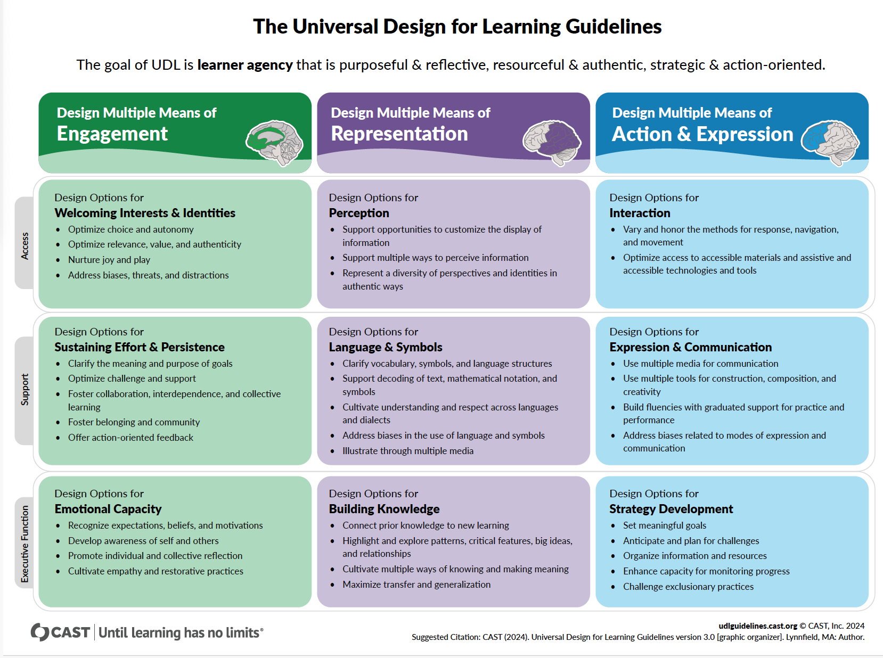Learn more about UDL, and see additional examples, at https://udlguidelines.cast.org/
Multiple Means of Representation (the “what” of learning)
Learners process information differently. Some may prefer reading, while others learn best through visuals, audio, or hands-on activities. UDL ensures content is presented in multiple formats so all students can engage.
Implementation Considerations:
- Present concepts in multiple formats i.e. text, images, diagrams, videos, and audio recordings
- Always ensure videos include closed captioning, provide transcripts for multimedia content, and offer printouts for slides shown during class
- Offer scaffolding techniques, such as graphic organizers or concept maps; and/or encourage students to try these strategies when presented with new materials
- Students have access to some popular podcasts through their DOC tablet. We cannot get additional things added, but we have in some cases been able to find episodes that instructors were able to use as course ‘reading’ material. Bring and ask students to look for the episodes well in advance, so an alternative reading can be provided should it not be available to them. Unfortunately, we haven’t yet been able to access a list of everything they have access to, despite attempts to do so.

Multiple Means of Action & Expression (the "how" of learning)

Students differ in how they express their knowledge. Some may struggle with writing but excel in verbal communication, while others may prefer creative projects. UDL provides various ways for students to demonstrate learning.

Implementation Considerations:

- Where possible, offer choices in assessments – perhaps students can create a zine, guide, comic strip, or other tool rather than an academic paper.
- When doing reflective activities, give students the option to write, draw, or talk through the topic with a peer.
- Provide clear, structured support for writing and organization; particularly when introducing students to a new style of writing/assessment.
- Design grading rubrics that allow for this variation, consider students verbal contributions, engagement in material, and quality of papers or assignments.

Multiple Means of Engagement (the "why" of learning)
Students are motivated by different factors. UDL promotes diverse strategies to foster interest, persistence, and self-regulation in learning.
Implementation Considerations:
- Connect learning to students’ personal experiences and interests
- Offer collaborative learning opportunities (peer discussions, group projects)
- Provide autonomy and choice in assignments and learning paths; or in how to execute an activity during class
- Incorporate self-reflection and goal-setting activities to build intrinsic motivation
_______________________________________________________________________

Curriculum Development Details & Logistics
We trust our professors to create curriculum in alignment with the specific course learning objectives, and FEPPS pedagogical principles discussed above. This section includes additional details, guidelines, and processes to be aware of as you prepare your curriculum and lesson plans throughout the quarter.

Classroom Infrastructure & Supplies
Room 6 is the FEPPS designated classroom, where the majority of our programming is held. It is located at the end of the hallway on the left. It is furnished with an instructor desk, TA desk, 2-person tables, chairs, filing cabinets and other storage, 2 whiteboards, projector screen, 2 computers, and supplies. You are welcome to rearrange the student tables and chairs into whatever format is most conducive to your course, however, please do not move the furniture along the edges of the classroom.
The classroom is regularly stocked with loose leaf paper, printer paper, pencils, pen, highlighters, white board markers, stapler, tape, 3-hole-punch, dictionaries, thesaurus, index cards, and fidgets. Other supplies are available, upon request – more details are provided below.

Technology
There is no access to the internet inside of the facility available to instructors or students. There are two computers in classroom 6, the one on the left requires DOC login, and the one on the right is available to instructors. This computer allows you to project on the screen, connect to speakers, and the printer. It is still possible for you to utilize slides, videos, and other technology while teaching – though it requires more preparation – explained in the sections below.

Standard Student Supplies
On the first day of class, every student is given the following supplies: notebook, folder, pens, pencils, highlighter, and loose-leaf paper. If you have created a course reader for students, this will also be given on the first day (See Course Readers, Novels, & Textbooks). When students take COL 101 in their first or second quarter, they are given a small dictionary. When students surpass the add/drop deadline for their second quarter in FEPPS, they are given a FEPPS backpack. There are additional pens, pencils, pencil lead, paper, etc. in classroom 6, though we ask that you do not give these out as it interferes with supply tracking – please grab a staff member to assist in these instances. If your class includes calculators, textbooks, or other specific supplies, please keep a sign-out sheet to track who has which items and request they be returned on the last day of class.

Requesting Course Supplies
The below list of supplies has been pre-approved by DOC, for FEPPS education. We can get anything you need from this list – simply email Shohei and Andrew with at least 1 week notice. If there are supplies, you’d like to have for your class that are not on this list, we will need to go through an approval process with DOC which can take a few weeks. Please reach out to Shohei as soon as possible, and no later than 3 weeks in advance, of when you hope to have them.
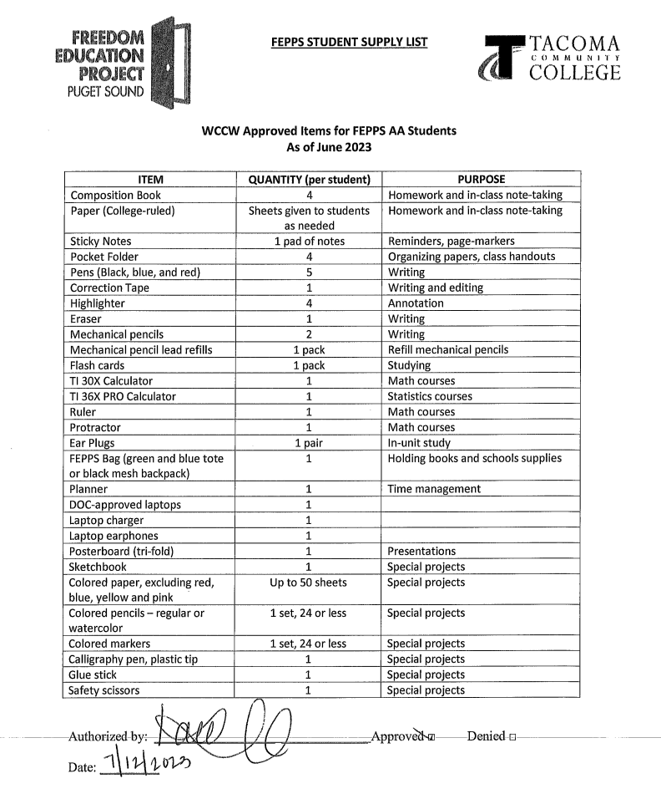
NOTE: Laptops are currently only available for BA students, though we hope to have them for AA students in the near future.

Curriculum & Lesson Plan Development
Syllabus Expectations
If your course has been offered by FEPPS in the past, FEPPS staff will share the syllabus with you for reference. The TCC general syllabus template, as well as COL 101 example syllabus also be found in the Appendix. Please note that the TCC general syllabus template includes information about Canvas as well as other technology and resources that are not available to students inside WCCW.
Your syllabus needs to include detailed information about the course readings and assignments are required for each date of class. Students should be able to use the syllabus as a guide to stay caught up, should they need to miss a class for any reason throughout the quarter.

Course Readers, Novels, & Textbooks
Shohei will let you know of any novels or textbooks we already have copies of relevant to your course subject, that can be used for your class. Materials may be purchased, if necessary and financially feasible. If your reading list includes articles, chapters, or other snippets of various texts, then a course reader may be best. Andrew will email you a OneDrive link, where you will need to upload all readings in pdf format, along with a Table of Contents sheet of the various readings you’ve provided. He will then coordinate their printing and bring them to class on the first day of class, assuming material is provided in a timely manner.

Lesson Presentation Slides, Videos, and Print Outs
There is no internet access in the facility (no google slides, no YouTube, no non-DOC email). You are still able to use presentations, videos, and other resources, just with a little more preparation and support from Andrew. Each class will have its own Dropbox for instructors to upload materials, that Andrew will then download and transfer to the classroom computer / print. Please follow the below guidelines when preparing to bring material inside:
Videos - Please email Andrew, and CC Shohei, at least two weeks before the day you plan to show the video and be sure to include the title of the video, video link, and the date of class you need it by.
PowerPoints and other non-video technology requests - Please upload the material(s) to Dropbox and email Andrew one week before, no later, when you will need said materials.
Printed Materials - upload the material(s) to Dropbox at least three business days prior to the day you are requesting the printouts, with the date it is needed in the file name, and email Andrew to notify him.

Bringing in Guest Speakers
Bringing guest speakers into your course is possible with appropriate reasoning and planning. Guests must first go through a DOC background check, for which they will request the individuals full legal name, birthdate, sex assigned at birth, and the last four digits of their SSN. Please reach out to Shohei or Evelyn as early as possible, and no later than 1 month prior to the desired date and they can assist with the process.

Supporting Students with Learning & Cognitive Disabilities
As mentioned above, support for students with disabilities is severely limited within this environment. We encourage all professors to provide students with a syllabus review, or other ‘welcome check-in' sheet, to learn more about students' individual needs and another check-in midway through the quarter (Example provided in ‘Appendix’). This allows you to be proactive and responsive to student accessibility needs and learning progress. FEPPS staff are resources to you and the student in brainstorming and implementing strategies.

Supporting Students in SEG
It is possible that a student will be sent to segregation while enrolled in your course. If this occurs, you’ll be informed by a FEPPS staff member once we’re aware, or sometimes sooner, a classmate that saw or heard about it. Generally, the shortest time someone spends in SEG is one week, while DOC conducts an investigation of the alleged infraction. Depending on the infraction, they may stay a few more days, weeks, or months. Shohei will work with both you and the student to determine whether it is feasible for them to continue in the course, with respect to the timing in the quarter, length of segregation sentence, and course curriculum. FEPPS staff do our best to support students in SEG, including staying enrolled in courses if possible.
People in segregation are kept within an isolation cell for 23 hours of the day and prevented from going to programming. They are, generally, not allowed to bring any of their items from their living unit with them. This means they will not have their course reader, syllabus, or notes from class with them. You will not be able to visit them with a red badge, however, a FEPPS staff member will do so and can bring paper between you and the student.
If a student is in SEG less than a week, we ask that you work with them to catch up in class when they return. If the student will be there longer than a week, you will be asked to provide a copy of your syllabus, any missed/upcoming assigned readings or assignments, and a brief note to the student clarifying instructions. As classes continue, FEPPS staff will continue to bring lecture print outs, worksheets readings, etc. to the student in SEG if they are able to remain in the class. We ask that you consider creating alternative assignments or ways for the student to engage in course materials remotely, if possible (Example provided in ‘Appendix’).
NOTE: If you are printing the material yourself, staples and paper clips are not allowed in segregation.

Other Relevant Resources Available to Students
Study Hall
FEPPS organizes two weekly study hall sessions each quarter for students. These are typically run by a FEPPS employee or volunteer. FEPPS alumni, student advisory council, or outside volunteer tutors regularly attend study hall to support our students with their work. If you are interested in supporting study halls or utilizing that time to meet with students in your course, please let Shohei know and it can be arranged.
Academic Advising
Our students are offered group advising sessions with our academic support team and individual advising appointments, around the middle of each quarter. If students have questions about their degree plan, pursuing education upon release, or anything else outside the scope of your course – please have them Kiosk FEPPS.
Tablets
Students have a DOC provided tablet, which is pre-loaded with Securus, movies, podcasts, and educational tools, and other applications that students are able to pay for. Tablets are generally kept in their living units, and not something they utilize for their formal education. We have had instructors in the past incorporate free podcasts found on student tablets into course material. Unfortunately, despite our attempts, we are unable to access a comprehensive list of what is available to students on this tablet. If there are specific tools or resources you are curious about, we encourage you to ask your students. (You can learn more about the implementation of tablets across U.S. prisons here).
Libraries
There are both a law library and state library in the education building, available to students. The state library (directly across from C building entrance) can assist students with some online research and printing articles. However, these are relatively limited and cannot be relied on without first talking with the librarian about their capacity and resources relevant to your course.
Extracurricular Opportunities
FEPPS runs a monthly Film Series and bi-monthly Critical Inquiry that is open to everyone at the facility. Critical Inquiry is a student-led reading group that discusses short articles, research, or other written works. Film Series is similar, but with media brought in from volunteers. If students are interested in being added to the callout (or waitlist) for these groups, they should kiosk FEPPS.
_______________________________________________________________________

Additional Resources for Continued Learning
On Liberatory, Anti-Racist, Feminist Pedagogy:
- Teaching to Transgress by bell hooks
- Abolitionist Teaching, Freedom Dreaming, and Black Joy by Bettina Love
- Pedagogy of the Oppressed by Paulo Freire
- Abolitionist Pedagogy is Necessary by Caroline Cheung
- Journal of Higher Education in Prison
On Accessible & Trauma Responsive Pedagogy:
- Building a Trauma Responsive Teaching Practice: Lessons From a Correctional Classroom by Em Daniels
- The UDL Guidelines
- The Politics of Trauma: Somatics, Healing, & Social Justice by Staci Haines
- Trauma Stewardship: An Everyday Guide to Caring for Self While Caring for Others by Laura Van Dernoot Lipsky & Connie Burk
On Mass Incarceration & the School-to-Prison Pipeline
- Mass Incarceration: The Whole Pie 2024
- Are Prisons Obsolete? by Angela Davis
- 13th
- Since I Been Down
- The School-to-Prison Pipeline: A comprehensive Assessment by Christopher Mallett
- Punished for Dreaming: How School Reform Harms Black Children and How We Heal by Bettina Love
- Ear Hustle
_______________________________________________________________________

References
Bertram, W. (2024). 6 Facts About the Incarceration of LGBTQ+ people. Prison Policy Initiative. https://www.prisonpolicy.org/blog/2024/06/04/lgbt_incarceration/

CAST (2024). Universal Design for Learning Guidelines version 3.0. Retrieved from https://udlguidelines.cast.org

Center for Substance Abuse Treatment (US). Trauma-Informed Care in Behavioral Health Services. Rockville (MD): Substance Abuse and Mental Health Services Administration (US). (2014). (Treatment Improvement Protocol (TIP) Series, No. 57.) Chapter 3, Understanding the Impact of Trauma. Available from: https://www.ncbi.nlm.nih.gov/books/NBK207191/

Crowe B. & Drew. C. (2021). Orange is the New Asylum: Incarceration of Individuals with Disabilities. Behavior Analysis in Practice(14). 387-395. https://doi.org/10.1007/s406107-020-00533-9
Daniels, E. (2022). Building a Trauma Responsive Educational Practice: Lessons from a correctional classroom. Routledge. https://doi.org/10.4324/9781003048312
Davidson, S. (2024). Trauma- and Resilience- Informed Practices for Postsecondary Education: A Guide. Education Northwest. https://educationnorthwest.org/sites/default/files/pdf/trauma-resilience-informed-practices-508c.pdf

Dweck, C. S. (2006). Mindset: The New Psychology of Success. Ballantine Books.
Kajstura, A. & Sawyer, W. (2024). Women’s Mass Incarceration: The Whole Pie 2024. Prison Policy Initiative. https://www.prisonpolicy.org/reports/pie2024women.html
Love, B. (2023). Punished for Dreaming: How School Reform Harms Black Children and How We Heal. New York city, NY: St. Martin’s Press.

Medina, J. (2008). Brain Rules: 12 principles for surviving and thriving at work, home and school. Pear Press.

Perry, B. (2006). Fear and Learning: Trauma-Related Factors in the Adult Education Process. New Directions for Adults and Continuing Education. Wiley. https://aztrauma.org/wp-content/uploads/2018/02/Adverse-learning-experiences-in-childhood-may-affect-the-ability-to-learn-through-the-lifespan.pdf

Prison Policy Initiative. (2025). Disability: Research on the prevalence of, and challenges faced by, people with disabilities in the criminal legal system. Prison Policy Initiative. https://www.prisonpolicy.org/research/disability/#:~:text=Key%20Statistics%3A,have%20a%20disability%3A%2023%25%20%2B
Prison Policy Initiative. (n.d.). Washington State Profile. Prison Policy Initiative. https://www.prisonpolicy.org/profiles/WA.html#articles
Vera Institute of Justice. (2019). Incarceration Trends in Washington. Vera Institue of Justice. https://vera-institute.files.svdcdn.com/production/downloads/pdfdownloads/state-incarceration-trends-washington.pdf
Villa, M. (2017). The Mental Health Crisis Facing Women in Prison. The Marshall Project. https://www.themarshallproject.org/2017/06/22/the-mental-health-crisis-facing-women-in-prison
Wolf Harlow, C. (2003). Bureau of Justice Statistics Special Report: Education and Correctional Populations. U.S. Department of Justice. https://bjs.ojp.gov/content/pub/pdf/ecp.pdf
_______________________________________________________________________

Appendix

Syllabus Review (Example)
Please read through the syllabus and then answer the questions below.
- After reviewing the syllabus, how do you feel about starting COL 101?

- What questions do you have about the syllabus?

- What is a concern or worry you have, starting COL 101?

- What topic(s) on the COL 101 syllabus are you most excited about?

- Are there ways I can structure material, class or information that would make it more accessible to you? (I.e. regular breaks during class, a seat closest to the white board, etc.)

- Is there anything else you would like to share with me so that I can best support you this quarter?

Mid-Quarter Check-In (Example)
Please take the time to respond to the following questions. The purpose of this check-in is for me to gauge how the class is going for you, and if there is anything I can be doing to better support you in the course.
- How are you managing the content of the course? This includes readings and the subjects covered in the class. How are you doing with the rigor and quantity of the work?

- What about the structure of class (how we spend class time) is working well for you? This could be icebreakers, small & large group discussions, group work, etc.).

- Is there anything about my teaching approach / practice that isn't working for you?

- Is there anything about my teaching approach / practice that works particularly well for you or that you would like me to do more of?

- Do you feel engaged during class time? Why or why not?

- Is there anything else you’d like to share with me that was not covered above?

Thank you 😊

Letter to Student in Segregation (Example)
Dear [Student],
I was informed that you are in segregation for the next couple of weeks – we miss having you in class and look forward to your return. In the meantime, FEPPS staff and I are working together to ensure you are able to stay caught up with course material.
Attached to this letter is a copy of our course syllabus, upcoming readings, and assignments. A FEPPS staff member will also visit you regularly to bring lecture slides, worksheets, and other course materials.
Alternative Engagement Plan
Since you are unable to participate in class discussions right now, you are encouraged to complete individual written reflections of course readings until you return to class. These reflections will allow you to engage with the course material in a more meaningful way, communicate your insights, and will contribute to ‘course participation’ points.
Reflection Guidelines
For each assigned reading, write a minimum 1-page reflection that includes the following:
- Summary of Key Points
  - What is the main argument or purpose of the reading?
  - What are the key ideas, themes, and takeaways?
- Critical Engagement
  - How does this reading connect to other course topics, previous readings, or your personal experiences?
  - What insights does it provide about education, power, and/or social change?
  - How does it challenge or reinforce your existing beliefs and assumptions?
- Application & Reflection
  - How can the ideas in this reading be applied to real-world contexts, including your own experiences or observations?
  - What questions does the reading raise for you?
Submission & Feedback
Please submit your reflections as they are completed to the FEPPS staff member when they visit, and they will leave them for me in the classroom. I will do my best to provide written feedback of any questions you highlight from the content in a timely manner.
Let me know if you have any questions or if there’s anything I can do to further support you with staying up to date with class material.
See you soon, Prof.

COL 101: Student Success (Example Syllabus)

Instructor Information  Nadra Fredj, M.Ed.  (they/she)  Kiosk: FEPPS | Course Information  College 101 | 5 credits  Autumn 2024  Monday & Wednesday1:30 – 3:50 p.m.  Room 6

Welcome to COL 101!
I am looking forward to getting to know you this quarter, and to be teaching this course with FEPPS for the third time. I have worked for the past 5 years working throughout university academic affairs and student support. Education is powerful, allowing us to learn about ourselves, our community, and our world. College courses are supposed to be challenging, but learning how to navigate the structure and system of college shouldn’t be. My goal in this course is to support you in identifying and developing skills that will enhance your education with FEPPS. Through this class, you will learn the tips, skills, and strategies to make the most out of your education.
Course Description
The purpose of this course is to facilitate students’ development of the capacities necessary to confidently navigate their unique college and career pathways. Topics may include: self-advocacy skills; leveraging students’ cultural capital; setting and achieving goals; academic planning; self-care and stress management; cultivating mentor, peer and community relationships; communication; career exploration; financial education; connecting with college and community resources; critical thinking related to equity, diversity, and inclusion; and information literacy.

Learning Outcomes
Upon successful completion of this course, students will be able to:
- Demonstrate effective communication and interpersonal skills in career and academic contexts to work collaboratively, solve problems, and perform tasks.
- Read and write to understand your own and others’ perspectives and cultural contexts.
- Grow social and emotional skills necessary to leverage your capacity to confidently transition to and navigate academic and professional environments.
- Locate and evaluate campus and community resources that contribute to successful completion of academic and professional goals.
- Recognize yourself as a learner and citizen capable of accomplishing your academic and professional goals and contributing to the larger community.
- Locate and evaluate relevant and authoritative information for academic and professional work.
- Apply critical thinking for academic and professional purposes.
- Explore career options and design personal, career, and educational plans.
- Recognize, understand, and critique current and social inequalities as it relates to your college and professional experiences.
- Engage in campus activities and reflect on how these activities relate to your college and professional experiences.

Course Material
All course materials will be provided. This will include: a composition book, folder, writing utensils, loose leaf paper, and course readings. All students also receive a dictionary which they are encouraged to keep as a resource.

Course Instructional Methods & Community Expectations
The course requires students to engage in self-reflection, practice organizational strategies, participate in discussions, engage in critical reading, and utilize both narrative and academic
writing to communicate ideas. Instructional methods include minimal lecturing, facilitated class
discussion, small group work, and individual reflection. The final hour of each Wednesday class
will be study hall, so students can incorporate the skills developed in COL 101 into their other
FEPPS courses.

This course is grounded in the belief that learning best happens in community, and that every person has a wealth of knowledge to contribute. You will get the most out of this when you come prepared, bring your own ideas into the discussions, lead with curiosity and care, and engage with everyone in the room. It is impossible to separate who we are as students from other aspects of our life; especially in a course like COL 101 where we are learning how we learn best. It is my goal, though it cannot be done by me alone, that we create a space in which we can all be curious, respectful, vulnerable, challenged, and encouraged.

Course Schedule
Below is our projected schedule for the course. This schedule may shift based on class needs, DOC closures, or other unforeseen circumstances. You will be promptly informed about any updates to the schedule in class.

(week) Date | Topic |  | Readings | Assignment Due
(1) Sept. 23 | Introductions & Syllabus
(1) Sept. 25 | Community & College Expectations |  | Kessel & Weinberger - What Are the Liberal Arts, Anyway?  Breman - Say This Not That  Fonseca – Strategies for Academic Success | Syllabus Review
(2) Sept. 30 | Close & Critical Reading |  | Adler & Van Duren – How to Read A Book CH. 5&7 | Bullet Journal Part 1
(2) Oct. 2 | Study Hall |  |  | Educational Autobiography
(3) Oct. 7 | Metacognition |  | Dweck – Mindset CH 1&2  Stanton, Sebesta, & Dunlosky – Fostering Metacognition to Support Student Learning & Performance
(3) Oct. 9 | Study Hall
(4) Oct. 14 | Executive Skills |  | Dawson & Guare - The Smart but Scattered Guide to Success CH 1-4 | Executive Skills Questionnaire p. 20-21
(4) Oct. 16 | Study Hall
(5) Oct. 21 | Stress & the Brain |  | Medina - Brain Rules: Stress  Freire - Don’t Let Fear of What is Difficult Paralyze You | Bullet Journal Part 2
(5) Oct. 23 | Study Hall
(6) Oct. 28 | Race, Culture & Education |  | Yosso - Whose Culture has Capital?  Lake – An Indian Father’s Plea
(6) Oct. 30 | Study Hall – Group Project Focus |  |  | Learning Log  Mid Quarter Check in (end of class)
(7) Nov. 4 | Imposter Syndrome & Stereotype Threat |  | Tulshyan & Burey – Stop Telling Women They Have Imposter Syndrome  TRIO (multiple authors) - Every Student Has a Story
(7) Nov. 6 | Study Strategies / Study Hall |  | Brown- Make It Stick CH 3&4
(8) Nov. 11 | NO CLASS - Veterans Day
(8) Nov. 13 | (Dis)Ability & Education |  | Gladwell - David Boies  Spiegel & Miller – How to Become Batman
(9) Nov. 18 | Liberated Scholars Panel or Since I Been Down Screening |  |  | Bullet Journal Part 3
(9) Nov. 20 | Study Hall
(10) Nov. 25 | Academic Planning & Career Exploration |  |  | Values Reflection due
(10) Nov. 27 | NO CLASS – Thanksgiving & Native American Heritage Day
(11) Dec. 2 | Self-Care |  | Brown & Wong – How Gratitude Changes Your Brain  SKIM: Wong et al. - Does Gratitude Writing Improve the Mental Health of Psychotherapy Patients? Evidence from a randomized controlled trial | Academic Plan
(11) Dec. 4 | Reading + Communicating Research |  |  | Group presentations
(12) Dec. 9 | Final Class Celebration |  |  | Group Project Reflection &  Final Paper
(12) Dec. 11 | HOLD

Assignments & Grading
The assessment structure for this course was created to assess your progress on the course learning outcomes. Detailed instructions and rubrics will be provided for each assignment at least 2 weeks before the deadline, except for the first two weeks. The table below shows the points possible and weight of each assessment category.
Category | Assignment Title | Due Date | Points | Percentage
Bullet Journal |  |  | 35 | 23
 | Set up (Part 1) | Sept. 30 | 20
 | Goal Setting (Part 2) | Oct. 21 | 10
 | Final Reflection (Part 3) | Nov. 18 | 5
Papers |  |  | 50 | 33
 | Educational Autobiography | Oct. 2 | 10
 | Values Reflection | Nov. 25 | 10
 | Learning Log | Oct. 30 | 10
 | Final Paper | Dec. 9 | 20
Group Project |  |  | 15 | 10
 | Presentation | Dec. 4 | 10
 | Reflection | Dec. 9 | 5
Other |  |  | 15 | 10
 | Syllabus Review | Sept. 25 | 5
 | Mid Q Check In | Oct. 30 | 5
 | Academic Plan | Dec. 2 | 10
Participation |  |  | 15 | 10
Total |  |  | 130 | 100

Reflective Papers
Intentional reflection on learning experiences is a cornerstone of personal, academic, and professional identity formation. Reflection is practice of the metacognitive process, allowing us to identify connections, identify questions, and process information. In this context, it also provides the instructor with a way of better understanding how students are experiencing their learning. While clear writing helps you better communicate your ideas, you will not lose points for grammar or spelling errors—although I might provide some proofreading suggestions to help you with future writing assignments.

Group Project
Students will work in groups of 4-5 to examine an academic research paper. The group will be responsible for synthesizing, critiquing, and presenting their academic paper to the rest of the class. After the presentation, students will complete a reflection of their work and collaboration with peers.

Bullet Journal
Time management and organization are important skills for student success. This course will introduce you to bullet journaling as a system for personal organization, and we will cover other strategies through the course. The bullet journal assignments help you practice this skill, and hopefully assist you with staying on track through the quarter. It will also be used as a reflective tool, to support your growth through the quarter.

Other Assignments
The Syllabus Review and Mid Quarter Check In assignments are tools for your instructor in curriculum development for the course. The Personal Academic Plan is a degree plan students will create in class, to be used as a tool as they progress through their DTA Degree.

Participation
Your regular attendance and active participation are necessary to make our sessions together worthwhile. Attendance is particularly important in the prison context, as it is our only chance to communicate with one another. I will look to you to volunteer your thoughts, ask questions and raise concerns—essentially, to guide us into the territory that will make this course most useful to your academic and personal growth. In order to do this well, the expectation is that you will come to each class having completed the assigned work, including the reading assignments for each day.

FEPPS adheres to the TCC Grading Rubric.

Grade | Percent
A | 93 to 100%
A- | 90 to 92%
B+ | 87 to 89%
B | 83 to 86%
B- | 80 to 82%
C+ | 77 to 79%
C | 73 to 76%
C- | 70 to 72%
D+ | 67 to 69%
D | 65 to 66%
E | 64% and below

Policies & Expectations
Attendance
If you know you will be missing a class, please let me know as soon as you can. If something unexpected occurs causing you to miss class, please write me a kite and give it to a classmate who can bring it on your behalf.

I recognize that there are unavoidable circumstances that sometimes make it impossible for you to attend class. Although I hope it isn’t the case, if you will not be in class for any reason, it is your responsibility to let me know in advance when possible. If something arises in between class sessions, you will need to communicate with me when you return. It is also your responsibility to consult with your peers on what content was missed, and to make up work missed in your absence. I encourage you to find a classmate from your unit in advance of missing class that can share notes and bring you materials from class. If after speaking with classmates you still have questions, please talk to me. Each student is allowed one absence without penalty; however, you should still communicate with me to ensure coverage of missed material. You can gain back participation points for a second missed absence by completing a 1-page reflection on the readings assigned for the missed class and completion of missed work (if applicable). Additional absences will impact the student’s participation grade.

Late Assignments
Assignments are due at the start of class on the date listed on the syllabus. We will frequently use an assignment as part of the class discussion or activity, and each assignment builds along with the course material. An assignment can, however, be turned in late for partial credit, though you will need to communicate with me regarding the circumstances.

Extension Requests
Students may be granted an extension if asked at least one class period before the assignment due date, and a reason is provided. These decisions will be made at the discretion of the instructor.

Class Cancellations
I will do my best to avoid cancelling class unless absolutely necessary and changes to the class will be communicated to you as soon as possible. If a class is cancelled day of, either by me or WCCW, it is expected that you come to the following class prepared for what is listed on the schedule, as you will have everything in advance. Any assignments that were due on the day a class is cancelled will be turned in the following class at no penalty.

Study Hall
Study halls are not mandatory but are highly encouraged. Study hall volunteers range from passionate community members to students from the University of Puget Sound, University of Washington, and other neighboring local universities and colleges. These volunteers will be available to help you with your work. Please contact FEPPS staff for more information about study hall and to sign up.

Academic Dishonesty
As stated in the TCC catalog, "Students are expected to be honest and forthright in their academic endeavors. Cheating, plagiarism, fabrication or other forms of academic dishonesty corrupt the learning process and threaten the educational environment for all students." Thus, all papers submitted are to be the student's own work. If the author of a paper borrows information without acknowledging the source, he or she is plagiarizing. Plagiarism and cheating (e.g., copying answers on exams or quizzes) will not be tolerated and will result in a grade of zero for that assignment (as well as forfeiture of opportunity to displace the lowest grade if applicable, and 10% reduction to overall grade). Further penalties, up to and including failing the course, may be applied.

Access and Accommodations
Your access in the learning environment is important to me. Please don’t hesitate to talk to me about ways I can make the class more accessible to you!

Course Bibliography
Adler, J.M. & Van Doren, M. (1972). How to Read a Book. Simon & Schuster.

Bremen, E. (2012). Say This, NOT That to Your Professor: 36 Talking Tips for College Success. NorLightPress.

Brock, K. & Brekken, K. (2019). No one Cared: A Case Study of Incarcerated Women's Educational Experiences Resulting in Their Decision to Drop Out of High School. Journal of Correctional Education, 70(2) 31-48. https://www.jstor.org/stable/26864181

Brown, P., Roediger III, H. L. McDaniel, M. A. (2014). Make it Stick: The science of successful learning. The Belknap Press.

Brown, J. & Wong, J. (2017 June 6.) How Gratitude Changes You and Your Brain. Greater Good Science Center. https://greatergood.berkeley.edu/article/item/how_gratitude_changes_you_and_your_brain

Crowe B. & Drew. C. (2021). Orange is the New Aylum: Incarceration of Individuals with Disabilities. Behavior Analysis in Practice(14). 387-395. https://doi.org/10.1007/s406107-020-00533-9

Dawson, P. & Guare, R. (2016). The Smart but Scattered Guide to Success: How to use your brain’s executive skills to keep up, stay calm, and get organized at work and at home. The Guilford Press.

Dweck, C. S. (2006). Mindset: The New Psychology of Success. (2006). Ballantine Books.

Fairbairn, F. (2021). Trust, power, and Transformation in the Prison Classroom. Journal of Prison Education and Reentry 7(2) 160-175. https://doi.org/10.25771/0694-3a92

Fonseca, Jordan. (2018). “Strategies for Academic Success: The Skills You Didn’t Know You Needed.”

Freire, P. (2005). Don’t Let Fear of What is Difficult Paralyze You. In Teachers as Cultural Workers: Letters to Those who Dare Teach. Taylor & Francis Group.

Gladwell, M. (2013). David Boies. In David and Goliath: Underdogs, misfits, and the art of battling giants (99-124). Back Bay Books.

Higgins, L. (2021). Exploring the Relationship Between Education and Rehabilitation in the Prison Context. Journal of Prison Education & Reentry 7(2) 144-159. https://doi.org/10.25771/mcrw-yw06

Kessel, A. Weinberger, S. (N.d.) “What Are the Liberal Arts, Anyway?” Department of Politics & Government.

Lake, R (Medicine Grizzlybear). (1990). An Indian Father’s Plea. Teacher Magazine 2(1) 48-53.

McCorkel, J., & DeFina, R. (2019). Beyond recidivism: Identifying the liberatory possibilities of prison higher education. Critical Education, 10(3), 1-19. https://doi.org/10.14288/ce.v10i7.186316

Medina, J. (2008). Brain Rules: 12 principles for surviving and thriving at work, home and school. Pear Press.

Moore, S. & Erzen, T. (2021). The Relationship Between Liberal Arts Classroom Experiences and the Development of Agency-Related Well-Being for Incarcerated Students. Journal of Higher Education in Prison 1(1), 30-49.

Stanton, J. D., Sebesta A. J., Dunlosky, J. (2021). Fostering Metacognition to Support Student Learning & Performance. Life Sciences Education 20(2). https://doi.org/10.1187/cbe.20-12-0289

Spiegel, A. & Miller, L. (Host). (2015 January 23). How to Become Batman [audio podcast episode]. Invisibilia. National Public Radio. https://www.npr.org/programs/invisibilia/378577902/how-to-become-batman

Tulshyan, R. & Burey, J.A. (2021 February 11). Stop Telling Women They Have Imposter Syndrome. Harvard Business Review. https://hbr.org/2021/02/stop-telling-women-they-have-imposter-syndrome?utm_medium=paidsearch&utm_source=google&utm_campaign=domcontent_bussoc&utm_term=Non-Brand&tpcc=domcontent_bussoc&gad_source=1&gclid=CjwKCAiA7t6sBhAiEiwAsaieYiy6B9bVt9gRRazQiLpNazIhQyOpDLDquzXpyanKShrPHJNjAlNAwRoCif0QAvD_BwE

Lenfestey, K. & Shubitha, K. (Ed.). (2016). Every Student Has a Story: Personal Narratives from First-Generation College Students. San Bernardino, California: TRIO Student Support Services.

Yosso, T. (2005). Whose culture has capital? A critical race theory discussion of community cultural wealth. Race Ethnicity and Education, 8(1) 69-91. https://doi.org/10.1080/1361332052000341006

Wong, J. Y., Brown J., Gabana, N. McInnis, S., Toth, P., & Gilman, L. (2016). Does Gratitude Writing Improve the Mental Health of Psychotherapy Clients? Evidence from a randomized controlled trial. Psychotherapy Research, 28(2) 192-202. https://doi.org/10.1080/10503307.2016.1169332

