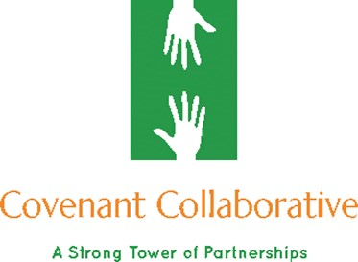
Covenant Collaborative Consulting & Training, LLC
NEX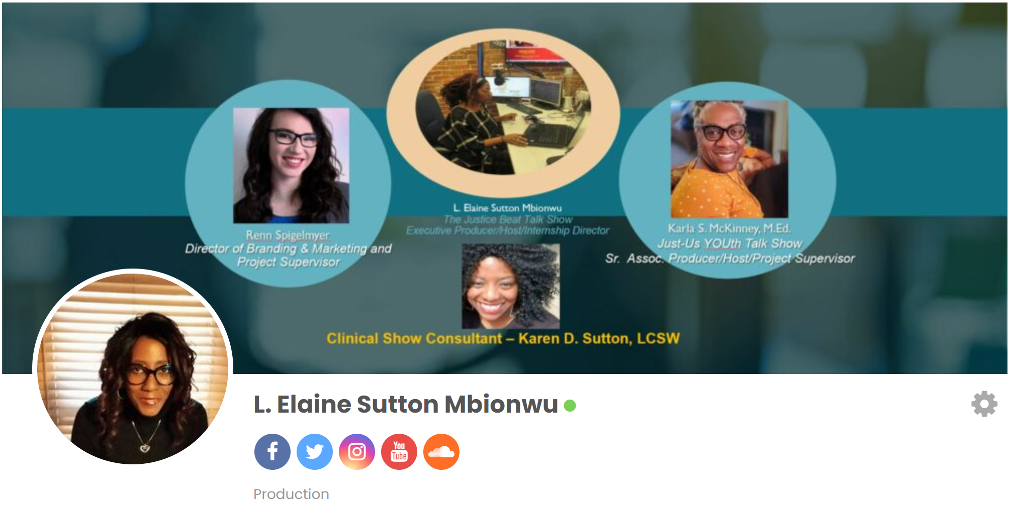
NEXT GENERATION MEDIA INTERNSHIP PROGRAM
NERAM
“Learning while Leading”
Next Generation Media Internship Program Description
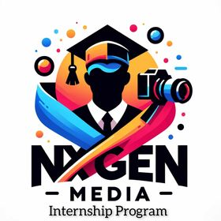

(REMOTE UNPAID ACADEMIC CREDIT PROGRAM)
Note: During COVID-19 Shelter-at-Home requirements, the Show is operating in a remote posture with show guest(s) appearing via Zoom until further notice. This remote opportunity requires access to desktop/laptop, dedicated workspace, and consistent internet access.
ONLY APPY IF YOU ARE PASSIONATE ABOUT AND KNOW YOUR “WHY” IS JUSTICE REFORM WITH AN INTEREST IN KNOWLEDGE TRANSLATION AND INFORMATION DISSEMINATION VIA PODCAST FORMAT.

IMDb approved The Justice Beat Talk Show just completed its year 7th season on April 20, 2024. Also, the signature show’s spin-off “Just-Us YOUth Talk Show” wrapped-up its’ 2nd season on April 27, 2024. WE WANT YOU to help us meet the demands of today’s EMERGING & EVOLVING MEDIA LANDSCAPE BY POSITIONING JUSTICE REFORM FRONT AND CENTER WITHIN THIS “AGE OF AI”. We recently launched the 8th season of the Justice Beat Talk Show and the 3rd season of the Just-Us YOUth Talk Show this past February for a 12-week season each podcast.
We are seeking individuals interested in creatively amplifying the needs of those impacted the collateral consequences of mass incarceration through knowledge translation and information dissemination across all social media platforms. Do you have a dream to work in the SOCIAL MEDIA/PODCASTING industry once you graduate from college/university? Are looking to put your classroom instruction/training into practical real-world experience? Join our production team and put your creative and technical skills to work as you operate in multiple areas of the production process amplifying justice reform.
With 12 Cohorts under our belt, what you will gain from the NxGen Media Program:
You will exercise your multi-tasking abilities as you assist in researching subject matter experts, future relevant topics, developing show ideas, identifying and booking potential show guest(s), editing episodes, updating FB show and podcast pages, and other activities as required. Through this observational, experiential-learning, and project-based you will have the opportunity to showcase your talent/skills by building a professional portfolio (body of work) in preparation for your chosen professional career path employment upon graduation while also
having an amazing experience as part of our production team. Employ your organizational skills as you contribute to the production workflow resulting in the timely and seamless product.

OVERVIEW OF LIVE IN-SEASON PRODUCTION TEAM RESPONSIBILITIES:
- Participate on the production team in the development of relevant stories for online talk show, online-streaming and other platforms.
- Story treatment for each episode, content creation, advance question development
- Research topics using a variety of sources, including video archives, the internet, library
archives and local newspapers, and other sources as needed.
- Communicate with show hosts and other team members to ensure a smooth running of the Show.
- Operate and manage functions associated with live-streaming show via Facebook Live.
- Editing, when necessary, live-show post-production.
- Engaging all social media platforms by advertising show schedule and upcoming guests
- Secure promotional material from confirmed guests (e.g., bios, photos, etc.) and post to all social media platforms.

SKILLS AND QUALIFICATIONS REQUIRED: o Enrolled in accredited college or university with ability to receive course credit.
o Serious interest in journalism, mass communication, media, or broadcast field.
  - Proficient in Microsoft Office, PowerPoint, Canva, Trello, FB Workplace, Garage Band, and OTC
  - o Problem-solving skills
  - Excellent communication skills (oral and written) o Working knowledge of social media platforms
  - Strong organizational skills
  - Timely and Efficient
  - Familiar with Meta/FB Creator Studio, FB Live Producer, Illustrator, Restream, Restream, Studio, and/or OBS
o Must have internet access and laptop

WEBMASTER TEAM
- Webmaster Team Lead (WORKFORCE DEVELOPMENT PARTICIPANTS AND UNIVERSITY STUDENTS UNDERGRADUATE/GRADUATE LEVEL)
- Webmaster Team Associate Interns (WORKFROCE DEVELOPMENT AND UNIVERSITY STUDENTS UNDERGRADUATE/GRADUATE LEVEL)
PRE-PRODUCTION/PRODUCTION TEAM/POST-PRODUCTION ROLES
- Team Lead
- Technical Production Lead
- Technical Production Assistant Intern
- Associate Producer Interns
- Project/Booking Assistant Intern
- Research Assistant Intern
- Videographer/Motions Graphics/Video Editor Intern
- Audio Blogger Intern
- Content Blogger Intern
- Social Media Intern
- Digital Content Creator – Online Community Digest Intern
- AI Repurpose Content Intern

BRANDING/MARKETING TEAM
Note: Ensuring all project efforts are properly branded for marketing and promotion purposes

SPECIAL PROJECTS
- Aliveshoes.com
- TEDx (University, Salon, and Virtual)
- All Things Justice Website
- All Things Justice Speakers Bureau
- All Things Justice E-Commerce Store
- YouTube Channel – Justice Beat Talk Show
- YouTube Channel – Just-Us YOUth Talk Show
- Fanbase Platform
- Clubhouse Platform
- Fanbase Platform
- Audio Blog

HOW TO APPLY:
Send a resume, cover letter, and portfolio of work product(s) to:
producer@thejusticebeat.com. Please indicate in your letter of interest, your availability (e.g., hours, days, etc.). Also, state whether you are interested in opportunities for Summer 2025, Fall 2025 or Winter/Spring 2026. Summer 2025 application deadline: May 1, 2025. Winter/Spring 2025 application deadline: November 1, 2025. NOTE: Required Hours during Academic Year: 10-12 hours per week. Days: Tuesday/Thursday. Time 10-4. Note: During academic school year, must be available for “mandatory” weekly debriefing Fridays from 9:30 a.m. – 10:30 p.m. CST and on Saturdays from 9:30 a.m. – 11:30 a.m. for live broadcast.

2025 Summer Session Timeline and Activities:
Focused Summer Activities: Upcoming Pre-production Team Activities, Post-production Team Activities, Webmaster Team Activities, Special Project Team Activities, and Branding/Marketing Team Activities

- May DATE TBD – Internship Interviews
- June DATE TBD - Self-paced New Intern Orientation and Training
- June DATE TBD – First full week of Internship Activity
- August 15th – Last Day of Internship Activity

FOR STL YOUTH JOBS PARTICIPANTS ONLY: Summer month (June/July/August) hours are 10:00 a.m. – 4:00 p.m. CST; Monday through Friday for a total of 30 hours per week. Mandatory participation in Weekly Debriefing/Group Supervision meetings at 9:30 a.m. CST. Incentives: Certificate of Completion, Certificate of Excellence-Business Solutions (select individuals based on performance) Letter of Recommendation, and Portfolio of Work Products.
NON-STL YOUTH JOB PARTICIPANTS: During the summer months, required part-time hours 20 hours/week as well as availability to participate in weekly production team meeting on Fridays (Time TBD). Incentives: Certificate of Completion, Certificate of Excellence-Business Solutions (select individuals based on performance) Letter of Recommendation, and Portfolio of Work Products.

L. Elaine Sutton Mbionwu
Creator/Executive Producer/Host & NxGen Media Program Director
E-mail: producer@thejusticebeat.com
Website: https://www.thejusticebeat.com
FB Show Page: https://www.facebook.com/justicebeat2day
FB Show Page: https://www.facebook.com/justusyouth
FB Online Community Forum: www.facebook.com/groups/justicebeat
IG, IGTV, and Twitter: @justicebeat2day; IG: @justusyouth; YouTube: @justicebeat2020
(All past episodes archived and ICYMI on-demand replay via YouTube @justicebeat2020
The Justice Beat Talk Show airs the 1stand 3rd Saturday of each month (February – April) from 10:00 a.m. - 11:00 a.m. CST and The Just-Us YOUth Talk Show airs on the 2nd and 4th Saturday of each month (February – April) from 10:00 a.m. – 11:00 a.m. CST via RESTREAM/FB Live/YT/Linkedin/IG


